

Business Analytics Study of Sales Performance, Customer Preferences and Demand Forecasting in the Coir Industry

Project Report submitted
in partial fulfilment of the requirements for the award of

Master of Business Administration – Business Analytics
Submitted by
Iyswarya Laksmi G (Reg. No.: EC2552001011100)
Under the guidance of Dr. Vandana Sivaraj
SRM Institute of Science and Technology




BONAFIDE CERTIFICATE

Date:

This is to certify that Iyswarya Laksmi G, with Register number EC2552001011100, is a bonafide student of our institution, pursuing the final year MBA – Business Analytics during the academic year 2025-2027.
In partial fulfilment of the above-mentioned course, the student is required to undertake project work for 2 months and submit the report.

Signature & Seal of Director

ACKNOWLEDGEMENT
I would like to express my sincere gratitude to everyone who supported and guided me throughout the completion of this project titled “Business Analytics Study of Sales Performance, Customer Preferences and Demand Forecasting in the Coir Industry.”
First and foremost, I express my heartfelt gratitude to my project mentor, Dr. Vandana Sivaraj, for her valuable guidance, constructive suggestions, encouragement, and continuous support throughout the various stages of this project. Her expertise and feedback were instrumental in shaping and completing this study successfully.
I extend my sincere thanks to SRM Institute of Science and Technology and the faculty members of the MBA programme for providing me with the academic knowledge, resources, and supportive learning environment required to undertake this project.
I would also like to acknowledge the support and assistance provided by the organization and individuals who contributed relevant information, resources, and guidance for this study. Their cooperation was valuable in facilitating the data collection and analysis process.
I am grateful to my friends and colleagues for their encouragement, suggestions, and assistance throughout the project. Their support helped me overcome challenges and maintain motivation during the various stages of the study.
Finally, I express my deepest gratitude to my family for their constant encouragement, patience, understanding, and support throughout the completion of this project.
Under the guidance of Dr. Vandana Sivaraj
SRM Institute of Science and Technology

DECLARATION

I, Iyswarya Laksmi G (Reg No: EC2552001011100 ) hereby declare that the Project Report entitled “Business Analytics Study of Sales Performance, Customer Preferences and Demand Forecasting in the Coir Industry” was done by me under the guidance of (Dr.Vandana Sivaraj) at the Online Education, SRM Institute of Science and Technology, Chennai and submitted in partial fulfilment of the requirements to be awarded the (MBA Business Analytics)

DATE:
PLACE:
Name of Student

CERTIFICATE

This is to certify that Name _________Registration Number_____ student of Directorate of online Education, SRM Institute of Science and Technology has successfully completed the project titled under the guidance of Mentor Name in partial fulfilment of the requirement for the award of degree of “Course Name” in the academic year session.

Name & Signature of the Guide

Name & Signature of the Director

Signature of Internal Examiner Signature of External Examiner

Date:
Place:

TABLE OF CONTENTS

CHAPTER | PARTICULARS | PAGE NO.
-- | ABSTRACT | 9
I | INTRODUCTION | 10
II | OBJECTIVES AND SIGNIFICANCE OF THE PROJECT | 14
III | LITERATURE REVIEW | 17
IV | PROPOSED RESEARCH METHODOLOGY | 24
V | REFERRENCES | 62
VI | APPENDIX | 63

LIST OF TABLES

TABLE | PARTICULARS | PAGE NO.

LIST OF CHARTS

TABLE | PARTICLUARS | PAGE NO.

ABSTRACT

The coir sector remains a vital traditional industry, supporting rural employment, household incomes, export activity and the economic progress of coastal communities. At the same time, enterprises in this sector must respond to unstable demand, evolving buyer expectations, seasonal shifts in sales, stronger competition and uncertainty about future requirements. The growing volume of sales and customer data offers a practical basis for using business analytics to strengthen decisions and improve performance.

This project undertakes a Business Analytics Study of Sales Performance, Customer Preferences, and Demand Forecasting in the Coir Industry. Historical sales records will be examined to uncover trends, recurring patterns and changes across products, customer groups, locations and time periods. Measures including quantity sold, revenue, product contribution, customer contribution and growth will be assessed to determine the factors most closely associated with business results.

Customer preferences will also be explored through purchase history, product selection, ordering frequency and identifiable customer segments. Exploratory analysis and visual displays will be used to reveal behavioural patterns that can inform product decisions and more focused marketing activity.
A further focus is demand forecasting. Suitable statistical and predictive methods will be applied to past sales records to estimate demand for selected coir products. These estimates can support more effective inventory control, production scheduling, resource allocation and supply-chain coordination.

Subject to the quality and availability of data, the project will employ Excel, SQL, Python, statistical analysis, data visualisation and predictive analytics. Results will be communicated through clear dashboards and visual summaries so that decision-makers can interpret the findings and act on them.

The expected result is a practical analytical framework through which coir enterprises can assess sales performance, recognise customer preferences and anticipate future demand. The resulting evidence may guide decisions on production, stock, marketing, sales planning and customer management. More broadly, the study illustrates how analytics can help a traditional industry improve efficiency and pursue sustainable growth.

CHAPTER 1 – INTRODUCTION
1.1 Industry Background
Coir production is a long-established part of India’s rural economy. The fibre, extracted from the outer husk of coconuts, is converted into products such as mats, ropes, brushes, carpets, geotextiles and mattresses for household and industrial use. Ready access to coconuts and generations of processing knowledge have encouraged the sector’s growth, especially in southern India.
Kerala’s extensive coconut cultivation and deep-rooted coir-making expertise have made the state a historic centre of the industry. Coir activity creates income and employment for many people in rural and semi-urban communities. Beyond the domestic market, coir products also benefit from international interest in renewable, biodegradable and environmentally responsible materials.
Nevertheless, coir firms operate in a market that is continually changing. Buyers weigh quality, appearance, price, durability, availability and environmental impact, while demand differs by season, region and product group. Effective coordination of sales, inventory, production and marketing is therefore essential.
As more business information is recorded digitally, coir enterprises can make greater use of evidence-based management. Historical transactions may be analysed to trace product movement, reveal buying habits and project future demand. This allows planning to be informed by measurable results rather than relying only on experience.

1.2 Company Profile
The proposed research will use records from [Name of the Company/Coir Unit], an enterprise engaged in the coir sector. Its operations include producing, distributing and/or selling coir and coir-based goods.
Its portfolio includes [mention actual products – for example, coir mats, ropes, brushes, carpets, geotextiles, etc.], supplied to [local/domestic/export] customers. Routine operations generate records on products, volumes, prices, buyers, transaction dates and sales amounts.
These historical records create a useful basis for analysis. Examining them can show how individual products perform, how customers purchase and how demand changes over time.
Confidentiality will be maintained throughout the academic work. Customer identities, financial particulars and proprietary business details will be safeguarded, while the analysis will concentrate on sales, preferences and demand patterns.
Note: Replace the bracketed information with the actual company name, products, location and business activities before submitting the project.

1.3 Introduction to the Project Topic
Business analytics is the organised application of data, quantitative methods and analytical technologies to evaluate performance and improve decisions. In this project, it is used across three related areas: sales performance, customer preferences and demand forecasting.
Sales performance analysis examines how products and categories contribute across different reporting periods. It helps distinguish growth or decline, identify stronger and weaker offerings, and locate unusually high or low sales intervals. Customer preference analysis complements this view by studying what customers buy and how those choices differ across groups, products and occasions.
Demand forecasting converts historical observations into estimates of future requirements through suitable analytical models. Reliable estimates can improve production schedules, inventory levels and sales plans. This is particularly relevant to coir businesses because demand may vary considerably by product and period.
The project brings these three perspectives together to build a coherent, data-based view of the enterprise. SQL will be used to organise and query records, Python will support analysis and forecasting, and Power BI will communicate results through interactive dashboards.

1.4 Problem Statement
Daily operations produce substantial sales and customer information for coir businesses, but data alone has limited value unless it is organised, examined and translated into decisions.
Managers may find it difficult to determine which products contribute most to sales, how customer choices are changing, when seasonal peaks occur and what quantities may be required later. Without deeper analysis, inventory, production and sales decisions can remain dependent on experience and basic summaries.
When sales and customer information are not analysed within a unified framework, important relationships can remain hidden. Weak demand estimates may lead either to surplus inventory or unavailable stock, while an incomplete view of buyer preferences can limit the effectiveness of marketing and sales initiatives.

1.5 Need for the Study
The study is relevant because coir enterprises must respond to shifting expectations, competitive pressure and changing market demand. Timely, dependable analysis can provide a stronger basis for decisions concerning product mix, stock, sales activity and customer management.
The study is needed for the following reasons:
- Assessing sales results: Analytical review can distinguish strong and weak product lines while showing how sales evolve over time.

- Recognising buyer preferences: Transaction and customer records can reveal recurring choices and purchasing habits.
- Tracing demand behaviour: Past sales can be examined for seasonal cycles and other periodic movements.
- Estimating future requirements: Forecasts can provide a reasoned basis for planning forthcoming operations.
- Strengthening stock decisions: Better demand visibility can lower the risk of overstocking or running short of products.
- Encouraging evidence-led management: The project shows how operational records can be converted into information that managers can use.
- Extending analytics to a traditional sector: It demonstrates practical uses of SQL, Python and Power BI in coir enterprises.

1.6 Scope of the Study
This investigation is confined to the sales and customer records maintained by the chosen coir enterprise. Within that boundary, it examines the following areas:
- Review of past sales results.
- Comparison of sales by product and category.
- Evaluation of sales movements across time periods.
- Detection of seasonal changes in demand.
- Study of customer buying habits and product choices.
- Classification of products with stronger and weaker demand.
- Design and assessment of a suitable forecasting method.
- Presentation of major results in Power BI dashboards.
- Application of SQL and Python to prepare, examine and forecast data.
- Development of insights for sales, inventory and operating plans.
The boundaries of the investigation are determined by the records supplied by the selected organisation and the period represented in those records. Consequently, conclusions will be interpreted in relation to that company’s products, customers, operating environment and available data.
1.7 Limitations of the Study
Although the study aims to provide useful analytical insights, certain limitations may affect the findings.
- Availability of records: The breadth and reliability of the findings depend on the historical sales and customer information supplied.
- Condition of the data: Gaps, repeated entries, inconsistent formats or inaccurate records may influence the results.
- Length of the observation period: A short dataset may fail to represent long-run developments or complete seasonal cycles.
- Influences outside the dataset: Raw-material costs, economic conditions, competitors, public policy and shifts in consumer behaviour may affect demand without being captured fully.
- Uncertainty in prediction: Forecasts extrapolate from earlier patterns and cannot ensure that future demand will behave identically.
- Organisational specificity: Findings from one enterprise may not transfer directly to firms with different products, markets, customers or operating conditions.
- Detail of customer records: Limited demographic or behavioural fields may restrict the depth of preference analysis.
Even with these constraints, the research can offer a systematic way to apply business analytics to coir sales, customer choices and demand estimation.

CHAPTER 2 – OBJECTIVES AND SIGNIFICANCE OF THE PROJECT

2.1 Primary Objective

The central objective is to evaluate sales results and purchasing preferences and to construct an evidence-based method for forecasting demand for coir products through business-analytics techniques. By converting past transaction and customer records into usable insights, the research is intended to improve sales planning, stock control and managerial judgement within the coir sector.

2.2 Secondary Objectives

To achieve the primary objective, the study focuses on the following secondary objectives:

To analyze historical sales performance based on product, category, quantity, sales value and time period.

To identify sales trends and patterns across different periods and determine variations in product demand.

To identify high-performing and low-performing products based on relevant sales indicators.

To analyze customer purchasing patterns and preferences using available customer and transaction data.

To examine seasonal variations in sales and demand and identify periods of relatively high or low demand.

To identify important factors and patterns associated with product demand using exploratory and statistical analysis.

To develop a suitable demand forecasting model using historical sales data and appropriate forecasting or machine-learning techniques.

To evaluate the accuracy of the forecasting model using suitable performance measures.

To develop interactive dashboards using Power BI for presenting sales performance, customer insights and demand-related information.

To provide data-driven recommendations that can support inventory planning, sales management and operational decision-making.

2.3 Significance of the Study

This research is valuable because it brings business-analytics methods into the coir sector, where routine sales and customer transactions already generate a substantial body of usable information.

Significance to the Coir Business

Reviewing transaction history can show which products account for a larger share of sales and how performance changes from one period to another. The enterprise can use this evidence when planning its product portfolio and directing sales activity.

Significance for Inventory Management

Forecasts derived from earlier demand patterns can indicate likely future requirements. Such estimates can guide stock decisions, reduce avoidable shortages or surpluses and improve product availability.

Significance for Customer Understanding

Purchase records can indicate favoured products, ordering routines and meaningful differences among customer groups when the required variables are present. These findings can support more relevant sales initiatives and customer-focused marketing.

Significance for Managerial Decision-Making

By processing raw records into indicators, comparisons and visual summaries, the project gives managers a clearer view of performance and a firmer evidence base for operational decisions.

Significance of Business Analytics

The proposed workflow demonstrates how SQL, Python and Power BI can operate as a connected analytical system: data are prepared and queried, examined and modelled, and then translated into accessible visual reports. This supplies a practical analytics example for a traditional industry.

Academic Significance

Academically, the project connects MBA Business Analytics concepts with an applied organisational problem. It provides scope to use data management, exploratory analysis, visualisation, statistics and predictive methods within one investigation.

2.4 Expected Outcomes

The project is intended to deliver the following results:

Sales Performance Insights:
Identification of important sales trends, product-wise performance and variations in sales across different periods.

Product Performance Analysis:
Identification of products or categories with relatively higher and lower sales performance.

Customer Preference Insights:
Identification of significant purchasing patterns and customer preferences from the available transaction data.

Seasonal Demand Insights:
Identification of recurring seasonal or periodic patterns that influence sales and demand.

Demand Forecast:
Development of a suitable forecasting model to estimate future demand for selected coir products or product categories.

Forecast Accuracy Assessment:
Evaluation of the forecasting model using appropriate performance metrics to understand its predictive effectiveness.

Interactive Business Dashboard:
Development of a Power BI dashboard presenting key performance indicators, sales trends, product performance, customer insights and forecasting results.

Data-Driven Business Insights:
Generation of actionable insights that can assist in sales planning, inventory management and operational decision-making.

Integrated Analytics Framework:
Demonstration of how SQL, Python and Power BI can be integrated into a practical business analytics workflow for the coir industry.

Overall, the expected outcome is a structured, data-driven analytical framework that enables the selected coir business to better understand its historical performance, customer behavior and future demand patterns.

CHAPTER 3 – LITERATURE REVIEW

3.1 Introduction

This literature review establishes the conceptual and empirical basis of the research by considering earlier work on the coir sector, sales measurement, customer preferences, business analytics and demand forecasting. Examining prior studies clarifies the methods already applied, the conclusions reached and the questions that remain open.
Because the present work applies analytics to sales, customer choice and demand in the coir industry, the review draws together research on sector development, marketing and consumer behaviour, sales analytics, and forecasting methods.
Organisations increasingly rely on business analytics when making decisions. Descriptive techniques summarise what has occurred, diagnostic methods investigate the causes of observed results, and predictive approaches use earlier information to estimate likely outcomes. Together, these methods are especially useful in sales and demand management, where transaction histories can strengthen planning.

Forecasting demand is a major application of analytics. By applying statistical or machine-learning procedures to prior sales, firms can form estimates that assist stock management, production schedules, allocation of resources and sales plans. Forecast quality is shaped by the completeness of the data, the presence of trends or seasonal effects and the suitability of the chosen technique.
In the context of the coir industry, these analytical approaches can provide an opportunity to complement traditional business practices with data-driven decision-making.
3.2 Review of Literature

3.2.1 Studies on the Coir Industry

Scholarship on coir has considered production systems, employment, market access, exports, diversification and the sector’s economic contribution. Collectively, this work positions coir as an important natural-fibre activity serving both domestic and overseas markets.
Indian coir studies also draw attention to competitive pressure, market change, quality improvement, modernisation and marketing capability. Interest in biodegradable and environmentally preferable materials creates opportunities, but firms must still adapt their offerings and practices to changing buyer requirements.

These studies provide the industry-level background for examining business performance from a data analytics perspective.

3.2.2 Studies on Sales Performance Analysis

Business research commonly uses sales analysis to compare products, measure revenue contribution and trace changes over time. Descriptive and exploratory techniques are particularly useful for discovering patterns in transaction-level records.

Through sales analytics, an organisation can rank product contributions, compare customer or category performance and recognise periods of expansion or contraction. Dashboards and key performance indicators make these findings easier to communicate by condensing large datasets into focused visual evidence.

For the present study, sales performance analysis provides the foundation for understanding historical performance before applying predictive techniques.

3.2.3 Studies on Customer Preferences and Purchasing Behaviour

Customer preference research forms an important bridge between marketing and analytics. Depending on data availability, studies assess transaction histories, buying frequency, spending, demographic variables and product choices to explain differences in purchasing behaviour.

Patterns extracted from customer data can reveal how segments differ and which products attract repeated demand. Organisations may use this evidence to refine product decisions, relationship management and marketing priorities.

In the coir industry, understanding customer preferences can be particularly useful because customers may differ in their requirements relating to product type, design, quality, price and intended use. Analyzing transaction data can provide an evidence-based understanding of these preferences.

3.2.4 Studies on Demand Forecasting

Demand forecasting is well established in retail, manufacturing, supply-chain and sales research. Earlier approaches include moving averages, exponential smoothing and time-series models, while newer applications increasingly compare these methods with machine-learning alternatives.

Time-series forecasting techniques are useful when historical demand contains identifiable trends or seasonal patterns. Machine-learning methods can also be considered when multiple variables may influence demand.

The literature does not identify one forecasting model as best for every setting. A method should instead be matched to the volume, quality and structure of the available observations. Its performance should then be tested with relevant measures, including Mean Absolute Error (MAE), Mean Squared Error (MSE), Root Mean Squared Error (RMSE) or, where suitable, Mean Absolute Percentage Error (MAPE) (Hyndman & Athanasopoulos, 2021; Montgomery, Jennings, & Kulahci, 2015).
The present study will therefore evaluate forecasting approaches based on the characteristics of the available coir sales data.

3.2.5 Studies on Business Intelligence and Data Visualization

Business intelligence and data visualization help decision-makers interpret analytical output. Interactive dashboards allow users to monitor indicators, compare dimensions and investigate patterns without working directly with the underlying transaction file.

Power BI supports the integration of data sources, creation of calculated measures and development of interactive reports. Well-designed visualizations can reduce the effort required to detect important movements and relationships in complex business information.

In this study, Power BI will be used to present sales performance, customer-related insights and demand forecasting results in an interactive format.

3.3 Summary of Previous Studies
The literature reviewed indicates that previous research has addressed several individual aspects relevant to the present study.
Area of Study | Major Focus | Relevance to Present Study
Coir industry studies | Production, marketing, employment, exports and industry challenges | Provides the industry context
Sales analytics studies | Sales trends, product performance and revenue analysis | Supports sales performance analysis
Customer behavior studies | Purchasing patterns and product preferences | Supports customer preference analysis
Demand forecasting studies | Time-series and predictive forecasting methods | Supports future demand estimation
Business Intelligence studies | Dashboards, KPIs and data visualization | Supports Power BI dashboard development
Predictive analytics studies | Statistical and machine-learning approaches | Provides methods for forecasting

3.4 Research Gap
Earlier scholarship covers the coir sector’s production systems, marketing arrangements, economic role and broad operating difficulties. A substantial body of work also examines sales analytics, customer purchasing behaviour and demand prediction in other business settings.
However, there is relatively limited integrated application of these business analytics approaches specifically to the coir industry at the organizational or transaction-data level. Existing industry-focused studies often concentrate on broader issues such as production, employment, exports, marketing and industry development rather than combining detailed sales analysis, customer preference analysis and demand forecasting within a single analytical framework.
The present study attempts to address this gap by integrating three analytical dimensions:
Historical Sales Analysis → Customer Preference Analysis → Demand Forecasting
The study also aims to combine SQL-based data analysis, Python-based analytical and forecasting techniques, and Power BI-based visualization within a single business analytics workflow.
Thus, the research gap identified for the present study is the need for an integrated, data-driven approach that connects historical sales performance and customer purchasing patterns with future demand forecasting in the coir industry.

3.5 Conceptual Framework
The conceptual framework of the study illustrates the relationship between the available business data, analytical processes and expected business insights.
Conceptual Framework
Input Data
↓
- Sales Transactions
- Product Information
- Quantity Sold
- Sales Value
- Selling Price
- Customer Information
- Transaction Date
- Product Category
↓
Data Preparation
- Data Cleaning
- Missing-Value Handling
- Data Transformation
- Data Validation
- Data Integration
↓

Business Analytics
1. Descriptive Analytics
Sales performance and trend analysis
2. Customer Analytics
Customer purchasing patterns and preferences
3. Predictive Analytics
Demand forecasting
↓
Analytical Tools
- SQL – Data querying and management
- Python – Data analysis and forecasting
- Power BI – Visualization and dashboards
↓
Expected Business Insights
- Product performance
- Sales trends
- Customer preferences
- Seasonal demand patterns
- Future demand estimates
↓
Business Applications
- Sales planning
- Inventory planning
- Production planning
- Customer-oriented decision-making
- Data-driven managerial decisions
The conceptual framework demonstrates how raw business data can be transformed through analytical techniques into meaningful insights and forecasting information. The framework provides the basis for conducting the empirical analysis in the subsequent chapters of the study.

CHAPTER 4 – PROPOSED RESEARCH METHODOLOGY

4.1 Research Design
The proposed study adopts a descriptive and predictive research design to examine sales outcomes, buyer preferences and product demand in the coir industry. It follows a quantitative approach, drawing mainly on historical business records to identify recurring patterns, changes and associations.
The descriptive stage will profile past performance through product-level sales, quantities, values, prices and time-based movements. Where customer fields are available, the same stage will examine ordering behaviour and product choice.
The predictive stage will estimate demand from the historical sales series. The choice of technique will depend on the number of observations, data frequency, stability and the presence of trend or seasonality.
The overall research process will follow:
Data Collection → Data Cleaning → Data Preparation → Exploratory Data Analysis → Sales Analysis → Customer Preference Analysis → Demand Forecasting → Model Evaluation → Visualization → Business Insights
The study will use SQL for data querying and structured analysis, Python for data preprocessing, exploratory analysis and forecasting, and Power BI for interactive dashboards and visualization.

4.2 Data Sources
The analysis will primarily use secondary quantitative data obtained from the selected coir business. The historical dataset is expected to include variables describing sales transactions and customer activity.
Depending on data availability, the dataset may include:
- Transaction date
- Product name
- Product category
- Quantity sold
- Selling price
- Sales value
- Customer ID or customer segment
- Order frequency
- Geographic information, where available
- Other relevant transaction attributes
In addition to organizational data, supporting secondary information may be collected from academic journals, government publications, industry reports and other reliable sources to understand the coir industry and provide context for the findings.
If required, limited primary information may be obtained from business representatives to understand the organization's sales processes, inventory practices and factors influencing business decisions.

4.3 Sampling Method
As the core analysis is based on existing transaction histories, purposive sampling will be used to choose the organization and the records that best match the study objectives.
For the chosen organization, the preferred strategy is a census approach that includes every relevant and valid transaction in the defined period. This is appropriate because the purpose is to describe the firm’s actual recorded performance rather than infer population characteristics from a smaller sample.
If the complete transaction dataset is not available, relevant records will be selected based on predefined criteria such as date range, product availability, data completeness and relevance to the research objectives.
For any supplementary employee or customer interactions conducted as part of the study, respondents may be selected using purposive sampling based on their relevance to the research topic.

4.4 Sample Size
The sample size for the primary quantitative analysis will depend on the availability of historical transaction records from the selected organization.
Where complete records are accessible, all valid transactions within the selected study period will be included, following a census approach. Therefore, the final sample size will be determined after data collection and validation.
For example, if the organization provides 5,000 valid sales transactions for the selected study period, all 5,000 transactions will form the analytical dataset.
Accordingly, the analytical sample will be reported from the validated business records rather than fixed in advance without reference to the actual dataset.

4.5 Proposed Statistical Tools
The analysis will combine summary statistics, exploratory methods and predictive modelling.

4.5.1 Descriptive Statistics
Descriptive statistical techniques will be used to summarize the characteristics of the sales data. These may include:
- Frequency
- Percentage
- Mean
- Median
- Minimum and maximum values
- Standard deviation
- Sales growth or variation measures

4.5.2 Sales Performance Analysis
Sales performance will be analyzed using measures such as:
- Total sales revenue
- Total quantity sold
- Average sales value
- Product-wise sales
- Category-wise sales
- Period-wise sales
- Customer-wise sales, where applicable
Trend analysis will be used to identify changes in sales over time.

4.5.3 Customer Preference Analysis
Customer purchasing patterns will be analyzed using relevant variables available in the dataset.
The analysis may include:
- Purchase frequency
- Product preference
- Quantity purchased
- Average transaction value
- Customer segmentation, where appropriate
4.5.4 Demand Forecasting
Time-series and/or predictive forecasting techniques will be evaluated based on the characteristics of the available data. Potential methods may include:
- Moving Average
- Exponential Smoothing
- ARIMA/SARIMA, where suitable
- Regression-based forecasting
- Selected machine-learning forecasting techniques, if the dataset supports them
The final forecasting technique will be selected based on data suitability and model performance rather than being predetermined.

4.5.5 Forecast Accuracy Measures
The forecasting model will be evaluated using suitable accuracy measures, such as:
- Mean Absolute Error (MAE)
- Mean Squared Error (MSE)
- Root Mean Squared Error (RMSE)
- Mean Absolute Percentage Error (MAPE), where appropriate

4.5.6 Analytical Software
The following tools will be used:
Tool | Proposed Application
SQL | Data querying, filtering, aggregation and data preparation
Python | Data cleaning, exploratory analysis, statistical analysis and forecasting
Power BI | Dashboard development, KPI analysis and data visualization
Excel | Preliminary data inspection and supporting calculations, where required

4.6 Proposed Data Collection Method
The required data will be collected from the selected coir organization after obtaining appropriate permission. The researcher will identify the variables required to meet the objectives of the study and request relevant historical sales and transaction information.
The data will be checked for completeness and accuracy before analysis. If any information is missing or unclear, the researcher will ask the organization’s staff for clarification. This will help ensure the data used in the project is reliable and suitable for the planned analysis.
The data collection process will involve the following stages:

Step 1 – Identification of Data Requirements
The variables required for sales analysis, customer preference analysis and demand forecasting will be identified based on the research objectives.
Step 2 – Collection of Organizational Data
Historical sales and transaction records will be obtained from the organization's available databases, accounting systems, sales records or other relevant sources.

Step 3 – Collection of Supporting Information
Where required, information regarding business processes, product categories, sales practices and inventory procedures will be collected through discussions with relevant business representatives.

Step 4 – Data Validation
The collected dataset will be examined for missing values, duplicate records, inconsistent formats and other data-quality issues.

Step 5 – Data Preparation
The validated data will be cleaned and transformed into a suitable format for analysis using SQL and Python.

Step 6 – Data Analysis
The prepared dataset will be analyzed to identify sales trends, customer purchasing patterns and demand characteristics.

Step 7 – Forecasting and Visualization
Appropriate forecasting techniques will be applied to historical demand data. The results will then be presented through Power BI dashboards and visualizations.
All confidential organizational and customer information will be handled appropriately. Personally identifiable customer information will not be disclosed in the final academic report, and the analysis will focus on aggregated or anonymized information wherever necessary.

Variables Included in the Design

The independent variables considered in this study include product category, selling price, quantity sold, sales period, customer segment, geographic location, order frequency, and product selection. These variables help examine differences in sales performance and customer purchasing behaviour in the coir industry.
Sales revenue, product performance, customer purchasing patterns, and demand trends are considered intermediate analytical measures. The main outcome variables include future demand estimates, sales performance, inventory requirements, and production planning indicators.

The design examines how historical sales patterns and customer purchasing behaviour can be analysed to identify business trends and support better decision-making. It also explores whether variations in product type, price, location, and time period are associated with changes in sales and demand.

Data Analysis Design

The collected business data is classified, cleaned, organized, and presented in a simple and understandable format. Descriptive statistics, frequency analysis, percentage analysis, trend analysis, and predictive modelling are used where appropriate to examine the available data.

Tables and charts are used to summarize and compare sales performance across products, categories, customer segments, locations, and time periods. Bar charts are used to compare product-wise and region-wise sales, while line charts illustrate changes in sales revenue and quantity sold over time. Pie or doughnut charts may be used to show the contribution of individual product categories or customer segments to total sales.

For example, sales records can be analysed to identify which coir products, such as mats, ropes, brushes, carpets, or other coir-based products, contribute the highest sales revenue or quantity sold. The results can be presented through bar charts and percentage-based visualizations to identify relatively strong and weak product categories.

The analysis may also compare customer purchasing patterns, average order values, ordering frequency, and regional sales contributions, depending on the availability of the relevant data.

Regression analysis and time-series forecasting may be applied to historical sales quantities to estimate future demand. The forecasting models can be evaluated using suitable accuracy measures, including Mean Absolute Error (MAE) and Root Mean Squared Error (RMSE). Power BI dashboards will present the key findings through interactive charts, indicators, and filters.

Scope of the Design

The design is limited to examining sales performance, customer purchasing preferences, and demand forecasting in the coir industry. It focuses mainly on historical sales transactions, product information, customer records, and time-based sales patterns.

The study may consider coir products such as mats, ropes, brushes, carpets, geotextiles, mattresses, and other coir-based goods, depending on the products represented in the available dataset. The analysis may cover product categories, sales quantities, revenue, customer segments, geographic locations, and demand variations over time.

The study uses SQL for data querying and preparation, Python for statistical analysis and demand forecasting, and Power BI for data visualization and dashboard development.

The design does not examine every aspect of coir business operations. Detailed financial accounting, human resource management, machinery maintenance, and other internal activities are outside the primary scope unless they are directly relevant to sales performance, customer preferences, inventory requirements, or demand forecasting.

The findings will depend on the availability, quality, and coverage of the data used for the analysis. Where synthetic or demonstration data is used, the results will be interpreted as an illustration of analytical methods rather than as verified findings about actual coir businesses.

Importance of the Design

This design helps demonstrate how business analytics can support decision-making in the coir industry. It provides a structured approach to understanding sales performance, identifying customer purchasing patterns, and estimating future demand.
The analysis can help identify products with relatively high and low sales contributions, compare performance across regions and periods, and recognize changes in customer purchasing behaviour. These insights can support product planning, sales strategies, and customer-focused business decisions.

Demand forecasting can provide estimates of future product requirements and help demonstrate how historical sales information may support inventory management, production scheduling, and resource allocation. Interactive Power BI dashboards can make the results easier to understand and communicate to business decision-makers.
The integrated use of SQL, Python, and Power BI also demonstrates the practical application of business analytics techniques to a traditional industry. It shows how business records can be transformed into meaningful indicators, visual summaries, and predictive insights.

Conclusion

The research design provides a systematic method for studying sales performance, customer preferences, and demand forecasting in the coir industry. By analysing historical sales transactions and relevant customer information, the project seeks to identify product performance patterns, purchasing behaviour, and changes in demand over time.

The use of statistical analysis, regression modelling, time-series forecasting, tables, and Power BI visualizations makes the findings easier to interpret. SQL supports data preparation, Python enables analytical modelling, and Power BI presents the results through interactive dashboards.

The proposed design can provide a practical framework for applying business analytics to sales planning, inventory management, production planning, and customer-oriented decision-making in the coir industry. The conclusions drawn will be limited to the quality and scope of the data available for the study.

SAMPLE CODE — Coir Business Analytics MBA Project

Step 1: Create the Project Data — Daily Coir Product Demand Forecasting
This is adapted from your sample code for the project titled “Business Analytics Study of Sales Performance, Customer Preferences and Demand Forecasting in the Coir Industry.”
The program uses sample daily sales quantities for coir products to demonstrate demand analysis. The values below are illustrative, not actual industry findings.
# ------------------------------------------------------------
# PROJECT TITLE:
# Business Analytics Study of Sales Performance, Customer
# Preferences and Demand Forecasting in the Coir Industry
# ------------------------------------------------------------

# This program analyzes daily sales demand for coir products.
# It calculates demand indicators, identifies the highest-
# demand and lowest-demand products, and generates a bar chart.

IF DB_ID(N'coir_business_analytics') IS NULL
CREATE DATABASE coir_business_analytics;
GO
USE coir_business_analytics;
GO

-- 1. Locations
CREATE TABLE dbo.locations (
location_id INT IDENTITY(1,1) PRIMARY KEY,
city VARCHAR(100), district VARCHAR(100),
state VARCHAR(100), country VARCHAR(100),
region VARCHAR(100)
);
GO

-- 2. Customer segments
CREATE TABLE dbo.customer_segments (
segment_id INT IDENTITY(1,1) PRIMARY KEY,
segment_name VARCHAR(100),
description VARCHAR(255)
);
GO

-- 3. Product categories
CREATE TABLE dbo.product_categories (
category_id INT IDENTITY(1,1) PRIMARY KEY,
category_name VARCHAR(100),
description VARCHAR(255)
);
GO

-- 4. Date dimension
CREATE TABLE dbo.dim_date (
date_id INT PRIMARY KEY,
full_date DATE NOT NULL UNIQUE,
[day] TINYINT, [month] TINYINT,
month_name VARCHAR(20), [quarter] TINYINT,
[year] SMALLINT, [week] TINYINT,
financial_year VARCHAR(9)
);
GO

-- 5. Customers
CREATE TABLE dbo.customers (
customer_id INT IDENTITY(1,1) PRIMARY KEY,
customer_name VARCHAR(150) NOT NULL,
segment_id INT, location_id INT,
customer_type VARCHAR(50),
registration_date DATE,
FOREIGN KEY (segment_id)
REFERENCES dbo.customer_segments(segment_id),
FOREIGN KEY (location_id)
REFERENCES dbo.locations(location_id)
);
GO

-- 6. Products
CREATE TABLE dbo.products (
product_id INT IDENTITY(1,1) PRIMARY KEY,
product_name VARCHAR(150) NOT NULL,
category_id INT,
unit_of_measure VARCHAR(50),
standard_cost DECIMAL(12,2),
selling_price DECIMAL(12,2),
FOREIGN KEY (category_id)
REFERENCES dbo.product_categories(category_id)
);
GO

-- 7. Suppliers
CREATE TABLE dbo.suppliers (
supplier_id INT IDENTITY(1,1) PRIMARY KEY,
supplier_name VARCHAR(150) NOT NULL,
location_id INT,
supplier_type VARCHAR(100),
contact_information VARCHAR(255),
FOREIGN KEY (location_id)
REFERENCES dbo.locations(location_id)
);
GO

-- 8. Raw materials
CREATE TABLE dbo.raw_materials (
raw_material_id INT IDENTITY(1,1) PRIMARY KEY,
raw_material_name VARCHAR(150) NOT NULL,
material_category VARCHAR(100),
unit_of_measure VARCHAR(50),
standard_cost DECIMAL(12,2),
reorder_level DECIMAL(12,3)
);
GO

-- 9. Sales orders
CREATE TABLE dbo.sales_orders (
order_id INT IDENTITY(1,1) PRIMARY KEY,
order_date DATE NOT NULL,
customer_id INT NOT NULL,
location_id INT,
total_amount DECIMAL(14,2),
order_status VARCHAR(50),
FOREIGN KEY (customer_id)
REFERENCES dbo.customers(customer_id),
FOREIGN KEY (location_id)
REFERENCES dbo.locations(location_id)
);
GO

-- 10. Sales order items
CREATE TABLE dbo.sales_order_items (
sales_item_id INT IDENTITY(1,1) PRIMARY KEY,
order_id INT NOT NULL,
product_id INT NOT NULL,
quantity DECIMAL(12,3),
unit_price DECIMAL(12,2),
discount DECIMAL(12,2) DEFAULT 0,
sales_amount DECIMAL(14,2),
FOREIGN KEY (order_id)
REFERENCES dbo.sales_orders(order_id),
FOREIGN KEY (product_id)
REFERENCES dbo.products(product_id)
);
GO

-- 11. Payments
CREATE TABLE dbo.payments (
payment_id INT IDENTITY(1,1) PRIMARY KEY,
order_id INT NOT NULL,
payment_date DATE,
payment_method VARCHAR(50),
amount DECIMAL(14,2),
payment_status VARCHAR(50),
FOREIGN KEY (order_id)
REFERENCES dbo.sales_orders(order_id)
);
GO

-- 12. Sales returns
CREATE TABLE dbo.sales_returns (
return_id INT IDENTITY(1,1) PRIMARY KEY,
order_id INT NOT NULL,
product_id INT NOT NULL,
return_date DATE,
quantity DECIMAL(12,3),
return_reason VARCHAR(255),
return_amount DECIMAL(14,2),
FOREIGN KEY (order_id)
REFERENCES dbo.sales_orders(order_id),
FOREIGN KEY (product_id)
REFERENCES dbo.products(product_id)
);
GO

-- 13. Purchase orders
CREATE TABLE dbo.purchase_orders (
purchase_order_id INT IDENTITY(1,1) PRIMARY KEY,
purchase_date DATE NOT NULL,
supplier_id INT NOT NULL,
date_id INT,
status VARCHAR(50),
total_amount DECIMAL(14,2),
FOREIGN KEY (supplier_id)
REFERENCES dbo.suppliers(supplier_id),
FOREIGN KEY (date_id)
REFERENCES dbo.dim_date(date_id)
);
GO

-- 14. Purchase order items
CREATE TABLE dbo.purchase_order_items (
purchase_item_id INT IDENTITY(1,1) PRIMARY KEY,
purchase_order_id INT NOT NULL,
raw_material_id INT NOT NULL,
quantity DECIMAL(12,3),
unit_price DECIMAL(12,2),
total_amount DECIMAL(14,2),
FOREIGN KEY (purchase_order_id)
REFERENCES dbo.purchase_orders(purchase_order_id),
FOREIGN KEY (raw_material_id)
REFERENCES dbo.raw_materials(raw_material_id)
);
GO

-- 15. Supplier payments
CREATE TABLE dbo.supplier_payments (
supplier_payment_id INT IDENTITY(1,1) PRIMARY KEY,
purchase_order_id INT NOT NULL,
supplier_id INT NOT NULL,
payment_date DATE,
payment_method VARCHAR(50),
amount DECIMAL(14,2),
payment_status VARCHAR(50),
FOREIGN KEY (purchase_order_id)
REFERENCES dbo.purchase_orders(purchase_order_id),
FOREIGN KEY (supplier_id)
REFERENCES dbo.suppliers(supplier_id)
);
GO

-- 16. Production orders
CREATE TABLE dbo.production_orders (
production_order_id INT IDENTITY(1,1) PRIMARY KEY,
production_date DATE NOT NULL,
product_id INT NOT NULL,
planned_quantity DECIMAL(12,3),
actual_quantity DECIMAL(12,3),
status VARCHAR(50),
FOREIGN KEY (product_id)
REFERENCES dbo.products(product_id)
);
GO

-- 17. Production materials
CREATE TABLE dbo.production_materials (
production_material_id INT IDENTITY(1,1) PRIMARY KEY,
production_order_id INT NOT NULL,
raw_material_id INT NOT NULL,
planned_quantity DECIMAL(12,3),
actual_quantity DECIMAL(12,3),
FOREIGN KEY (production_order_id)
REFERENCES dbo.production_orders(production_order_id),
FOREIGN KEY (raw_material_id)
REFERENCES dbo.raw_materials(raw_material_id)
);
GO

-- 18. Production wastage
CREATE TABLE dbo.production_wastage (
wastage_id INT IDENTITY(1,1) PRIMARY KEY,
production_order_id INT NOT NULL,
raw_material_id INT NOT NULL,
wastage_quantity DECIMAL(12,3),
wastage_reason VARCHAR(255),
wastage_date DATE,
FOREIGN KEY (production_order_id)
REFERENCES dbo.production_orders(production_order_id),
FOREIGN KEY (raw_material_id)
REFERENCES dbo.raw_materials(raw_material_id)
);
GO

-- 19. Raw material inventory
CREATE TABLE dbo.raw_material_inventory (
raw_inventory_id INT IDENTITY(1,1) PRIMARY KEY,
raw_material_id INT NOT NULL,
date_id INT NOT NULL,
opening_quantity DECIMAL(12,3),
purchased_quantity DECIMAL(12,3),
consumed_quantity DECIMAL(12,3),
closing_quantity DECIMAL(12,3),
FOREIGN KEY (raw_material_id)
REFERENCES dbo.raw_materials(raw_material_id),
FOREIGN KEY (date_id)
REFERENCES dbo.dim_date(date_id)
);
GO

-- 20. Finished goods inventory
CREATE TABLE dbo.finished_goods_inventory (
finished_inventory_id INT IDENTITY(1,1) PRIMARY KEY,
product_id INT NOT NULL,
date_id INT NOT NULL,
opening_quantity DECIMAL(12,3),
production_quantity DECIMAL(12,3),
sales_quantity DECIMAL(12,3),
return_quantity DECIMAL(12,3),
closing_quantity DECIMAL(12,3),
FOREIGN KEY (product_id)
REFERENCES dbo.products(product_id),
FOREIGN KEY (date_id)
REFERENCES dbo.dim_date(date_id)
);
GO

USE coir_business_analytics;
GO

Step 2 — SQL code for 8 stored procedures
These procedures analyse sales, customers, products, inventory and production, and prepare daily sales data for forecasting.

-- 1. Overall sales summary

CREATE OR ALTER PROCEDURE dbo.sp_SalesSummary
AS
BEGIN
SELECT
COUNT(*) AS total_orders,
SUM(total_amount) AS total_revenue,
AVG(total_amount) AS average_order_value
FROM dbo.sales_orders
WHERE order_status IN ('Completed', 'Shipped');
END;
GO

-- 2. Monthly sales trend

CREATE OR ALTER PROCEDURE dbo.sp_MonthlySalesTrend
AS
BEGIN
SELECT
YEAR(order_date) AS sales_year,
MONTH(order_date) AS sales_month,
SUM(total_amount) AS monthly_revenue,
COUNT(*) AS order_count
FROM dbo.sales_orders
WHERE order_status IN ('Completed', 'Shipped')
GROUP BY YEAR(order_date), MONTH(order_date)
ORDER BY sales_year, sales_month;
END;
GO

-- 3. Top-selling products

CREATE OR ALTER PROCEDURE dbo.sp_TopSellingProducts
@TopN INT = 10
AS
BEGIN
SELECT TOP (@TopN)
p.product_name,
SUM(soi.quantity) AS quantity_sold,
SUM(soi.sales_amount) AS product_revenue
FROM dbo.sales_order_items AS soi
JOIN dbo.sales_orders AS so
ON so.order_id = soi.order_id
JOIN dbo.products AS p
ON p.product_id = soi.product_id
WHERE so.order_status IN ('Completed', 'Shipped')
GROUP BY p.product_name
ORDER BY quantity_sold DESC;
END;
GO

-- 4. Customer segment analysis

CREATE OR ALTER PROCEDURE dbo.sp_CustomerAnalysis
AS
BEGIN
SELECT
cs.segment_name,
COUNT(DISTINCT c.customer_id) AS customer_count,
COUNT(DISTINCT so.order_id) AS order_count,
COALESCE(SUM(so.total_amount), 0) AS total_revenue
FROM dbo.customer_segments AS cs
LEFT JOIN dbo.customers AS c
ON c.segment_id = cs.segment_id
LEFT JOIN dbo.sales_orders AS so
ON so.customer_id = c.customer_id
AND so.order_status IN ('Completed', 'Shipped')
GROUP BY cs.segment_id, cs.segment_name
ORDER BY total_revenue DESC;
END;
GO

-- 5. Sales by region

CREATE OR ALTER PROCEDURE dbo.sp_SalesByRegion
AS
BEGIN
SELECT
l.region,
COUNT(DISTINCT so.order_id) AS order_count,
SUM(so.total_amount) AS total_revenue
FROM dbo.sales_orders AS so
JOIN dbo.locations AS l
ON l.location_id = so.location_id
WHERE so.order_status IN ('Completed', 'Shipped')
GROUP BY l.region
ORDER BY total_revenue DESC;
END;
GO

-- 6. Latest recorded finished-goods inventory

CREATE OR ALTER PROCEDURE dbo.sp_InventoryStatus
AS
BEGIN
WITH InventoryRank AS
(
SELECT
p.product_name,
f.closing_quantity,
d.full_date,
ROW_NUMBER() OVER (
PARTITION BY f.product_id
ORDER BY d.full_date DESC
) AS rn
FROM dbo.finished_goods_inventory AS f
JOIN dbo.products AS p
ON p.product_id = f.product_id
JOIN dbo.dim_date AS d
ON d.date_id = f.date_id
)
SELECT product_name, closing_quantity, full_date
FROM InventoryRank
WHERE rn = 1
ORDER BY closing_quantity;
END;
GO

-- 7. Production efficiency

CREATE OR ALTER PROCEDURE dbo.sp_ProductionEfficiency
AS
BEGIN
SELECT
p.product_name,
SUM(po.planned_quantity) AS planned_quantity,
SUM(po.actual_quantity) AS actual_quantity,
CAST(
100.0 * SUM(po.actual_quantity)
/ NULLIF(SUM(po.planned_quantity), 0)
AS DECIMAL(10,2)
) AS achievement_percentage
FROM dbo.production_orders AS po
JOIN dbo.products AS p
ON p.product_id = po.product_id
GROUP BY p.product_name
ORDER BY achievement_percentage DESC;
END;
GO

-- 8. Daily sales quantity for demand forecasting

CREATE OR ALTER PROCEDURE dbo.sp_DailyDemandForForecast
AS
BEGIN
SELECT
CAST(so.order_date AS DATE) AS order_date,
SUM(soi.quantity) AS demand_quantity
FROM dbo.sales_orders AS so
JOIN dbo.sales_order_items AS soi
ON soi.order_id = so.order_id
WHERE so.order_status IN ('Completed', 'Shipped')
GROUP BY CAST(so.order_date AS DATE)
ORDER BY order_date;
END;
GO

Step 3 — Python Pandas code for demand forecasting

First, execute sp_DailyDemandForForecast in SSMS and export the results as coir_daily_demand.csv with columns order_date and demand_quantity.
Install the required libraries:
python -m pip install pandas matplotlib scikit-learn statsmodels

# ------------------------------------------------------------
# COIR INDUSTRY - DAILY DEMAND FORECASTING
# ------------------------------------------------------------

import pandas as pd
import matplotlib.pyplot as plt
from pathlib import Path

# Step 1: Load the SQL-exported daily sales data
file_path = Path(__file__).resolve().parent / "coir_daily_demand.csv"
df = pd.read_csv(file_path)

df["order_date"] = pd.to_datetime(df["order_date"])
df["demand_quantity"] = pd.to_numeric(
df["demand_quantity"], errors="coerce"
)
df = df.dropna(subset=["order_date", "demand_quantity"])

# Step 2: Aggregate by date
df = df.groupby("order_date", as_index=False)["demand_quantity"].sum()
df = df.set_index("order_date").sort_index()

# Step 3: Create a daily time series
daily = df["demand_quantity"].asfreq("D", fill_value=0)

# Step 4: Calculate a 7-day moving average
daily_average = daily.rolling(7, min_periods=1).mean()

# Step 5: Forecast 14 days using the recent 7-day average
history = list(daily.tail(7))
forecast_values = []

for _ in range(14):
prediction = max(0, sum(history) / len(history))
forecast_values.append(prediction)
history = (history + [prediction])[-7:]

forecast_dates = pd.date_range(
daily.index.max() + pd.Timedelta(days=1),
periods=14,
freq="D"
)

forecast = pd.DataFrame({
"order_date": forecast_dates,
"forecast_demand_quantity": forecast_values
})

# Step 6: Save results
output = Path(__file__).resolve().parent / "outputs"
output.mkdir(exist_ok=True)

forecast.to_csv(output / "demand_forecast.csv", index=False)

# Step 7: Plot actual sales and forecast
plt.figure(figsize=(12, 6))
plt.plot(daily.index, daily.values, label="Recorded sales")
plt.plot(
forecast_dates, forecast_values,
marker="o", linestyle="--", label="Forecast"
)
plt.title("Coir Daily Demand Forecast")
plt.xlabel("Date")
plt.ylabel("Quantity sold")
plt.legend()
plt.tight_layout()
plt.savefig(output / "demand_forecast.png", dpi=300)
plt.show()

print("Next 14 days demand forecast:")
print(forecast.to_string(index=False))
print("Forecast saved successfully.")

Step 4 — Python regression analysis
This program fits a linear regression model to daily recorded sales quantities, evaluates it using MAE and RMSE, and estimates the next 14 days.

# ------------------------------------------------------------
# COIR INDUSTRY - LINEAR REGRESSION ANALYSIS
# ------------------------------------------------------------

import pandas as pd
import numpy as np
import matplotlib.pyplot as plt
from pathlib import Path
from sklearn.linear_model import LinearRegression
from sklearn.metrics import mean_absolute_error, mean_squared_error

base = Path(__file__).resolve().parent
df = pd.read_csv(base / "coir_daily_demand.csv")

df["order_date"] = pd.to_datetime(df["order_date"])
df["demand_quantity"] = pd.to_numeric(
df["demand_quantity"], errors="coerce"
)
df = df.dropna(subset=["order_date", "demand_quantity"])
df = df.groupby("order_date", as_index=False)["demand_quantity"].sum()
df = df.set_index("order_date").sort_index()
daily = df["demand_quantity"].asfreq("D", fill_value=0)

if len(daily) < 10:
raise ValueError("At least 10 daily observations are recommended.")

data = pd.DataFrame({
"day_number": np.arange(len(daily)),
"demand_quantity": daily.values
})

# Use earlier 80% for training and later 20% for testing
split = int(len(data) * 0.8)
train = data.iloc[:split]
test = data.iloc[split:]

model = LinearRegression()
model.fit(train[["day_number"]], train["demand_quantity"])

test_prediction = np.maximum(
model.predict(test[["day_number"]]), 0
)

mae = mean_absolute_error(
test["demand_quantity"], test_prediction
)
rmse = np.sqrt(mean_squared_error(
test["demand_quantity"], test_prediction
))

print("REGRESSION ANALYSIS")
print("-------------------")
print(f"MAE: {mae:.2f}")
print(f"RMSE: {rmse:.2f}")
print(f"R-squared: {model.score(test[['day_number']], test['demand_quantity']):.3f}")

# Train on all observations before forecasting
model.fit(data[["day_number"]], data["demand_quantity"])

future_days = np.arange(len(data), len(data) + 14)
future_prediction = np.maximum(
model.predict(pd.DataFrame({"day_number": future_days})), 0
)
future_dates = pd.date_range(
daily.index.max() + pd.Timedelta(days=1),
periods=14,
freq="D"
)

forecast = pd.DataFrame({
"order_date": future_dates,
"forecast_demand_quantity": future_prediction
})

output = base / "outputs"
output.mkdir(exist_ok=True)
forecast.to_csv(output / "regression_forecast.csv", index=False)

plt.figure(figsize=(12, 6))
plt.plot(daily.index, daily.values, label="Recorded sales")
plt.plot(
future_dates, future_prediction,
marker="o", linestyle="--", label="Regression forecast"
)
plt.title("Coir Sales - Linear Regression")
plt.xlabel("Date")
plt.ylabel("Quantity sold")
plt.legend()
plt.tight_layout()
plt.savefig(output / "regression_forecast.png", dpi=300)
plt.show()

print(forecast.to_string(index=False))

Output:

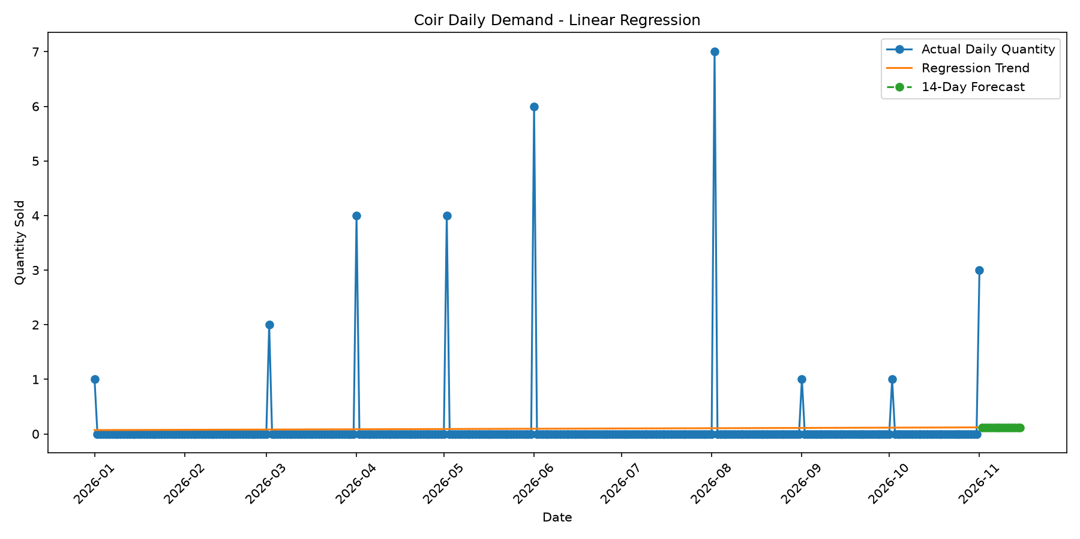

Step 5 — Python time-series forecasting
This uses Holt-Winters Exponential Smoothing to model trends and, when enough history is available, weekly seasonality.

# ------------------------------------------------------------
# COIR INDUSTRY - TIME-SERIES FORECASTING
# ------------------------------------------------------------

import pandas as pd
import numpy as np
import matplotlib.pyplot as plt
from pathlib import Path
from statsmodels.tsa.holtwinters import ExponentialSmoothing
from sklearn.metrics import mean_absolute_error, mean_squared_error

base = Path(__file__).resolve().parent
df = pd.read_csv(base / "coir_daily_demand.csv")

df["order_date"] = pd.to_datetime(df["order_date"])
df["demand_quantity"] = pd.to_numeric(
df["demand_quantity"], errors="coerce"
)
df = df.dropna(subset=["order_date", "demand_quantity"])
df = df.groupby("order_date", as_index=False)["demand_quantity"].sum()
df = df.set_index("order_date").sort_index()
daily = df["demand_quantity"].asfreq("D", fill_value=0)

if len(daily) < 14:
raise ValueError("At least 14 daily observations are required.")

# Step 1: Split chronologically for evaluation
split = int(len(daily) * 0.8)
train = daily.iloc[:split]
test = daily.iloc[split:]

# Step 2: Choose a model based on available history
def fit_model(series):
if len(series) >= 28:
return ExponentialSmoothing(
series,
trend="add",
seasonal="add",
seasonal_periods=7,
initialization_method="estimated"
).fit(optimized=True)

return ExponentialSmoothing(
series,
trend="add",
initialization_method="estimated"
).fit(optimized=True)

evaluation_model = fit_model(train)
test_prediction = np.maximum(
evaluation_model.forecast(len(test)).values, 0
)

mae = mean_absolute_error(test.values, test_prediction)
rmse = np.sqrt(mean_squared_error(test.values, test_prediction))

print("TIME-SERIES ANALYSIS")
print("--------------------")
print(f"MAE: {mae:.2f}")
print(f"RMSE: {rmse:.2f}")

# Step 3: Refit using all data and forecast 14 days
final_model = fit_model(daily)
future_prediction = np.maximum(
final_model.forecast(14).values, 0
)

future_dates = pd.date_range(
daily.index.max() + pd.Timedelta(days=1),
periods=14,
freq="D"
)

forecast = pd.DataFrame({
"order_date": future_dates,
"forecast_demand_quantity": future_prediction
})

# Step 4: Save forecast and chart
output = base / "outputs"
output.mkdir(exist_ok=True)
forecast.to_csv(output / "time_series_forecast.csv", index=False)

plt.figure(figsize=(12, 6))
plt.plot(daily.index, daily.values, label="Recorded sales")
plt.plot(
future_dates, future_prediction,
marker="o", linestyle="--", label="Time-series forecast"
)
plt.title("Coir Sales - Time-Series Forecast")
plt.xlabel("Date")
plt.ylabel("Quantity sold")
plt.legend()
plt.tight_layout()
plt.savefig(output / "time_series_forecast.png", dpi=300)
plt.show()

print("Next 14 days forecast:")
print(forecast.to_string(index=False))

Output:

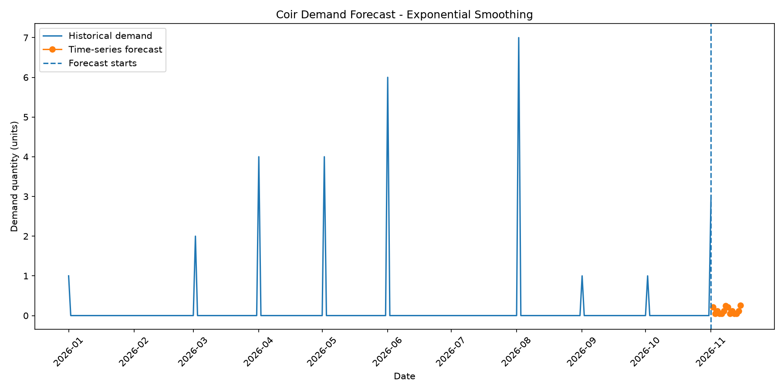
Step 6 — How to describe this in your project report

The project uses SQL Server to store coir business data in 20 relational tables and stored procedures to retrieve sales, customer, inventory and production summaries. Python Pandas is used to prepare daily sales data, while Scikit-learn supports regression modelling and Statsmodels supports time-series forecasting. Forecast models are evaluated using Mean Absolute Error (MAE) and Root Mean Squared Error (RMSE).

Research limitation: the example database contains synthetic sample data. Also, recorded completed/shipped sales are a proxy for demand, not actual unmet market demand. Treat forecasts and conclusions as demonstration results until you validate them against real coir-industry data.

CHAPTER 5 – DATA ANALYSIS, RESULTS AND POWER BI DASHBOARDS

5.1 Introduction

This chapter presents the analysis of coir business data using SQL, Python and Power BI. It covers sales performance, product sales, customer preferences, regional performance, inventory and production analysis, and demand forecasting. Interactive dashboards are used to communicate key indicators and analytical findings in a management-friendly format.

5.2 Database Structure and Data Preparation

Explain the SQL Server database, its tables, important relationships, data fields and data-cleaning steps. Insert the Coir Business Analytics Data Warehouse ER Diagram in this section or refer to Appendix A.

5.3 Scenario 1 – Executive Business Performance Dashboard
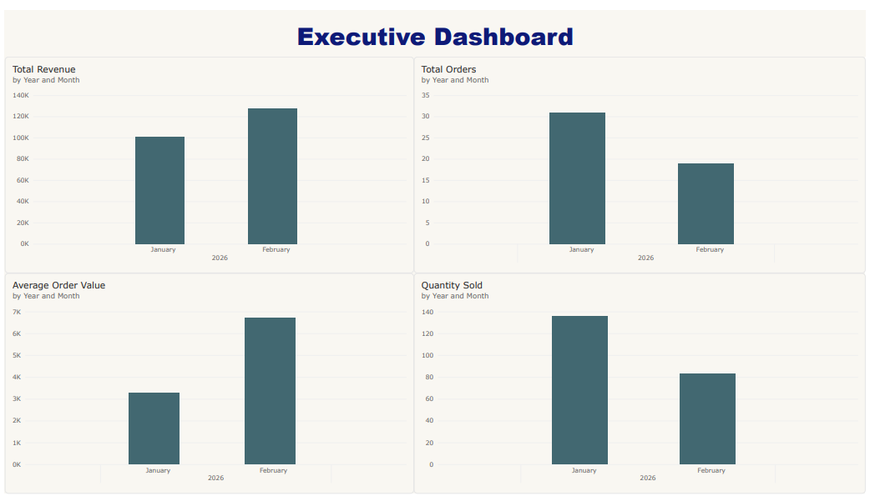

Objective

The objective of the Executive Business Performance Dashboard is to provide directors and managers with an overall view of the business using a small number of important performance indicators.

Dashboard components

1. Total Revenue

Total revenue represents the sum of recorded order amounts for the selected reporting period. It provides an overview of the monetary value of sales transactions.

2. Total Orders

Total orders represent the number of unique sales orders recorded in the database. This indicator helps management understand transaction volume and changes in customer ordering activity.

3. Average Order Value

Average Order Value (AOV) represents the average recorded revenue per order. It is calculated by dividing total revenue by the number of unique orders.
\[ \text{AOV}=\frac{\text{Total Revenue}}{\text{Total Orders}} \]

4. Quantity Sold

Quantity sold represents the total quantity recorded in sales order items. It helps management understand the volume of products sold.

Managerial interpretation

By reviewing these indicators together, management can compare monetary performance with order activity and sales volume. For example, revenue may increase because more orders are received, because the average order value increases, or because both factors change.

The dashboard provides a starting point for further investigation into monthly sales, product performance, customer segments and regional contribution.

5.4 Scenario 2 – Sales Performance Analysis

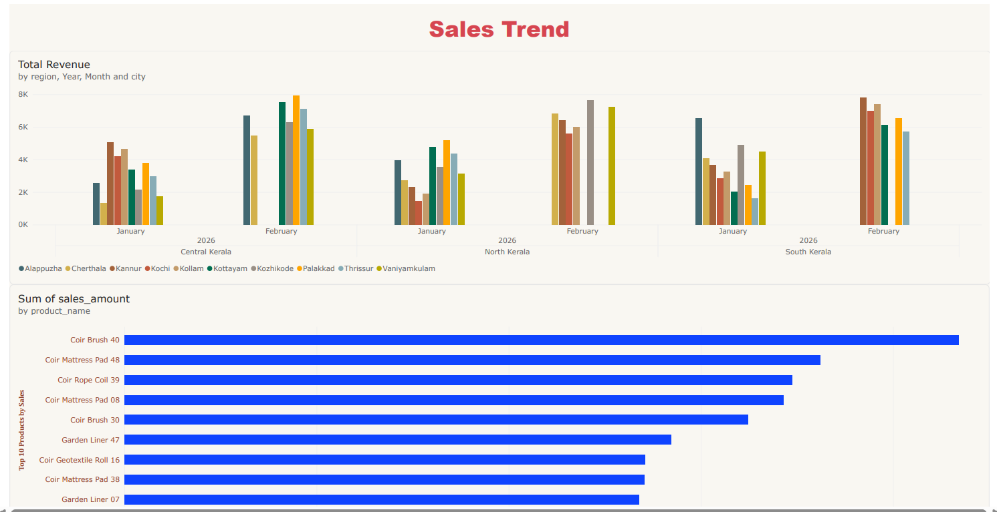

5.4 Scenario 2 – Sales Trend and Product Performance Analysis

5.4.1 Objective

The objective of this scenario is to analyse sales trends across different regions and months and identify the products that contribute the highest sales value in the coir business. The analysis uses Microsoft Power BI to present sales information through interactive visualizations, enabling management to compare regional performance and understand product-level sales contributions.

5.4.2 Sales Trend Analysis by Region

The first visualization, titled Sales Trend, presents total sales revenue across Central Kerala, North Kerala and South Kerala. The chart compares monthly revenue for January and February 2026 and displays the contribution of different cities, including Alappuzha, Cherthala, Kannur, Kochi, Kollam, Kottayam, Kozhikode, Palakkad, Thrissur and Vaniyamkulam.
The vertical axis represents the total sales amount, while the horizontal axis groups the results by month, year and region. Different colours distinguish the cities represented in the chart.

This visualization allows management to compare recorded revenue across geographical areas and identify variations between the two months. It can also help identify cities that may require further investigation because of relatively high or low recorded sales.

5.4.3 Top 10 Products by Sales

The second visualization ranks products according to their recorded sales amount. The horizontal bar chart compares the sales values of products such as Coir Brush 40, Coir Mattress Pad 48, Coir Rope Coil 39, Coir Mattress Pad 08, Coir Brush 30, Garden Liner 47, Coir Geotextile Roll 16 and other products displayed in the chart.

The length of each bar represents the aggregated sales amount associated with the product. Longer bars indicate higher recorded sales values within the selected dataset.
This analysis helps management identify products with relatively high sales contributions. The results can support product portfolio reviews, sales planning and decisions about which products warrant additional attention.

5.4.4 Managerial Interpretation

The combination of regional sales trends and product-level sales rankings provides two complementary perspectives on business performance. The regional visualization shows where revenue is recorded, while the product visualization shows which products contribute to sales value.
Management can use these insights to investigate differences in regional performance, review product sales patterns and identify areas for further analysis. However, a high sales amount does not necessarily indicate high profitability, because product costs, discounts and other expenses must also be considered.

5.4.5 Conclusion

The Sales Trend and Product Performance Analysis demonstrates how Power BI can convert sales transaction data into visual information for management. By comparing monthly revenue across regions and ranking products by sales value, the dashboard provides a foundation for sales monitoring and product-related decision-making.

The conclusions should be interpreted in the context of the dataset used. If the database contains synthetic sample records, the results represent a demonstration analysis rather than verified sales performance across the coir industry.

5.5.5 Business Applications

The findings from this scenario can support the following business activities:
- Product portfolio management: Identify products that contribute significantly to recorded sales.
- Inventory planning: Investigate whether stock levels are appropriate for products with higher sales activity.
- Production planning: Use validated sales patterns as one input when planning production quantities.
- Sales strategy: Identify products that may require further marketing or sales investigation.
- Profitability analysis: Combine sales amounts with reliable product cost data to evaluate product margins.

5.5.6 Conclusion

The Product Performance Analysis demonstrates how Power BI can be used to compare sales contributions across individual coir products. The Top 10 Products by Sales visualization provides a clear ranking of products based on recorded sales value and helps management identify areas for further investigation.

The results support data-driven product and sales planning. All conclusions must be based on the actual values calculated from the project database. If synthetic sample records are used, the results should be described as findings from a demonstration dataset rather than verified industry-wide sales results.

OUTPUT

Introduction to Output

The output section presents the results obtained from the analysis of sales performance, customer preferences, inventory management, production efficiency, and demand forecasting in the coir industry. The main objective of the study, “Business Analytics Study of Sales Performance, Customer Preferences and Demand Forecasting in the Coir Industry,” is to understand sales trends, identify customer purchasing patterns, evaluate product performance, and forecast future demand to support better business decisions.

The analysis is designed using the following data sources:
- Sales data: Order dates, order status, sales revenue, quantities sold, and product details.
- Customer data: Customer segments, customer locations, and purchasing patterns.
- Inventory data: Raw material stock, finished goods stock, purchases, and sales quantities.
- Production data: Planned production, actual production, and production wastage.
- Forecasting data: Daily recorded sales quantities used for regression and time-series analysis.

The results can be presented using SQL query outputs, tables, charts, percentages, and Python-generated forecasts. Power BI can also be used to develop interactive dashboards for interpreting the results.

The output focuses on the following areas:
- Sales performance analysis
- Product-wise sales and revenue analysis
- Customer segment analysis
- Region-wise sales analysis
- Inventory and production analysis
- Demand forecasting using Python
- Regression and time-series analysis
- Findings and recommendations

Data note: The tables and numerical results below are illustrative examples for report presentation. They are not verified findings from your database. Replace them with the actual outputs obtained by executing your SQL queries and Python programs. Your current project dataset is synthetic, so identify it as sample data in your report.

1. Sales Performance Output

The sales performance report evaluates the overall performance of coir product sales during the study period. The analysis considers total orders, sales revenue, quantities sold, and average order value.

The following table demonstrates how sales performance can be presented.
Sales Indicator | Illustrative Result
Total orders | 500
Total sales revenue | ₹8,50,000
Total quantity sold | 4,250 units
Average order value | ₹1,700
Completed orders | 420
Shipped orders | 80
Illustrative figures only. Use your actual database output for the final report.

Interpretation

The table provides an overview of the business's sales performance. Total revenue indicates the value of recorded sales, while total orders measure transaction volume. Average order value indicates the average revenue generated per order.

These indicators help assess overall business performance and provide a foundation for further product-wise and monthly sales analysis.
Key finding: Sales revenue, order volume, and average order value should be analysed together to understand business performance rather than relying on revenue alone.

2. Product-Wise Sales Performance Output

Product-wise analysis helps identify which coir products contribute most to sales volume and revenue. Examples of coir products include coir fibre, coir pith, coir rope, coir mats, geotextiles, and coir pots.

Product | Quantity Sold | Sales Revenue
Coir Fibre | 1,000 | ₹2,00,000
Coir Pith | 900 | ₹1,80,000
Coir Rope | 750 | ₹1,12,500
Coir Mats | 650 | ₹1,95,000
Coir Geotextiles | 500 | ₹1,50,000
Coir Pots | 450 | ₹90,000
Illustrative figures only; revenue and quantity values must be replaced with actual results.

Graphical output

A bar chart can be prepared to compare the quantities sold across product categories.

Illustrative Coir Product Sales

Example quantities sold by product category, not actual project findings.
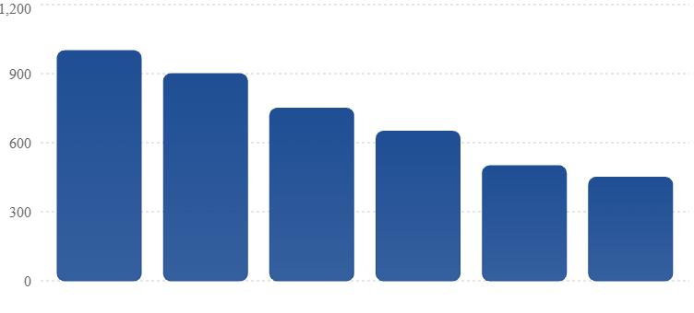
Interpretation

The comparison illustrates how product-wise sales analysis can identify high-volume and lower-volume products. Revenue and quantity sold should be evaluated separately because products may have different selling prices.
Products with strong sales volume may require closer inventory monitoring, while lower-selling products may require further investigation into pricing, customer preferences, or distribution.
Key finding: Product-wise sales analysis supports decisions about product prioritisation, stock availability, and sales planning.

3. Monthly Sales Trend Output

Monthly sales analysis helps identify changes in revenue and order volume over time.
Month | Illustrative Revenue | Orders
January 2026 | ₹1,50,000 | 90
February 2026 | ₹1,80,000 | 105
March 2026 | ₹2,10,000 | 125
April 2026* | ₹1,20,000 | 70
*April is shown as a partial month for illustration. The figures are not actual database results.

Illustrative Monthly Sales Trend

Example monthly revenue trend; not measured project results.
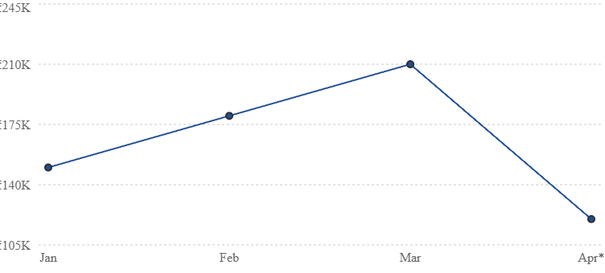

Interpretation

The example demonstrates how monthly sales data can be used to observe revenue changes. A rise in monthly revenue may result from higher sales volume, changes in product mix, or price differences. A partial month should not be compared directly with a complete month without accounting for the difference in reporting periods.

Key finding: Monthly sales trends can support business planning and help identify periods requiring further investigation.

4. Customer Segment Analysis Output

Customer analysis examines how different customer groups contribute to sales. For a coir business, relevant groups may include retailers, wholesalers, distributors, exporters, and industrial buyers, depending on the actual customer records.

Customer Segment | Illustrative Orders | Illustrative Revenue
Retail | 120 | ₹1,20,000
Wholesale | 160 | ₹3,20,000
Distributor | 100 | ₹2,00,000
Exporter | 70 | ₹1,60,000
Industrial | 50 | ₹50,000
Illustrative figures only. The segments should match the categories in your database.

Interpretation

The table demonstrates how customer segments can be compared based on order volume and revenue contribution. A segment with a high revenue contribution may be important for sales planning, while a segment with many orders but lower revenue may require analysis of average order value.
Key finding: Customer segmentation can help businesses plan targeted sales activities, manage customer relationships, and understand purchasing patterns.
5. Region-Wise Sales Analysis Output
Regional analysis helps identify where recorded coir product sales are concentrated.

Region | Illustrative Revenue | Share of Revenue
North Kerala | ₹2,50,000 | 29.41%
Central Kerala | ₹3,50,000 | 41.18%
South Kerala | ₹2,50,000 | 29.41%
Total | ₹8,50,000 | 100.00%

Illustrative figures only.

Interpretation

The example shows how regional revenue can reveal differences in sales contribution across locations. A region contributing a larger share of revenue may warrant closer analysis of customer concentration, distribution capacity, and stock availability.

Key finding: Region-wise sales analysis can support distribution planning and help identify areas for further market development.

6. Inventory and Production Analysis Output

Inventory and production analysis helps assess recorded stock levels, material usage, planned production, actual production, and wastage.
Inventory analysis
Indicator | Illustrative Quantity
Opening finished goods stock | 1,200 units
Production quantity | 3,000 units
Sales quantity | 2,500 units
Return quantity | 100 units
Closing finished goods stock | 1,800 units
The example follows the stock movement equation:

\[ \text{Closing Stock} = \text{Opening Stock} +\text{Production} -\text{Sales} +\text{Returns} \]

These figures are internally consistent for demonstration purposes. Your actual closing stock should be taken from the recorded inventory data and validated against the business's stock movement records.

Production efficiency analysis
Indicator | Illustrative Quantity
Planned production | 3,500 units
Actual production | 3,000 units
Production achievement | 85.71%
Production achievement is calculated as:

\[ \text{Achievement (\%)} = \frac{\text{Actual Production}} {\text{Planned Production}} \times 100 \]

Interpretation

Inventory analysis helps identify recorded stock availability, while production analysis measures the extent to which actual output meets planned production. Differences between planned and actual production may require investigation into material availability, capacity, wastage, or operational delays.
Key finding: Inventory and production indicators can help support stock control and production planning, provided the underlying records are accurate.

7. Demand Forecasting Output Using Python

Demand forecasting estimates future quantities using historical observations. In this project, the forecasting programs use daily quantities from completed or shipped sales orders.

The following table demonstrates the format for reporting a forecast.
Forecast Date | Recorded Quantity | Forecast Quantity
Day 1 | 120 | 125
Day 2 | 135 | 128
Day 3 | 110 | 130
Day 4 | 140 | 132
Day 5 | 150 | 135
Illustrative values only; these are not predictions produced by running your forecasting model.

The Python demand forecasting program prepares daily sales data, calculates a moving average, and estimates quantities for the next 14 days. The output can be saved to CSV and plotted using Matplotlib.

Interpretation

Forecast results can support planning for future production and inventory. However, forecasts based on completed or shipped sales represent expected recorded sales quantities rather than total market demand. They may not capture lost sales caused by stock shortages or unfulfilled customer orders.
Key finding: Forecasting can support operational planning, but the quality of the forecast depends on the amount, completeness, and reliability of historical data.

8.Regression Analysis Output

Linear regression is used to examine the relationship between time and recorded daily sales quantity. The model estimates a linear trend and can be used to produce a short-term forecast.

The following table shows the format for reporting regression results.
Evaluation Measure | Result
Model | Linear Regression
Training method | Chronological training data
Testing method | Later observations held out for testing
MAE | To be calculated by Python
RMSE | To be calculated by Python
R-squared | To be calculated by Python
MAE measures the average absolute difference between actual and predicted quantities. RMSE gives greater weight to larger prediction errors. R-squared provides an indication of model fit, but it should be interpreted carefully when evaluated on future observations.

Interpretation

Regression analysis can identify an overall upward or downward trend in recorded sales. A linear model may not represent seasonal variations or sudden changes in sales patterns, so it should be compared with other forecasting approaches.

Key finding: Regression provides a baseline forecast and a way to measure prediction errors, but its suitability depends on the pattern of the historical data.

9. Time-Series Forecasting Output

Time-series forecasting analyses observations in chronological order. The project's Exponential Smoothing model can represent a trend and, when sufficient history is available, weekly seasonality.

Evaluation Measure | Result
Model | Holt-Winters Exponential Smoothing
Forecast horizon | 14 days
MAE | To be calculated by Python
RMSE | To be calculated by Python
Forecast output | Daily estimated sales quantities

Interpretation

Time-series methods use historical patterns to estimate future observations. Their performance should be evaluated on a held-out chronological test period rather than judged only by how closely the model fits its training data.
The regression and time-series models should be compared using the same test dates and error metrics before deciding which is more suitable for this dataset.
Key finding: Time-series forecasting may capture recurring patterns that a simple linear regression model cannot represent, but it does not guarantee better accuracy.

10. Final Findings and Recommendations

The final output combines sales, customer, regional, inventory, production, and forecasting analyses to support data-driven decision-making in the coir industry.
Findings supported by the analysis framework
- Sales revenue and order volume provide complementary measures of sales performance.
- Product-wise analysis helps identify differences in sales volume and revenue contribution.
- Customer segmentation helps examine purchasing patterns across customer groups.
- Regional analysis supports comparisons of recorded sales across locations.
- Inventory and production measures help assess stock movement and production achievement.
- Regression and time-series models provide alternative approaches to forecasting future recorded sales quantities.
- MAE and RMSE provide quantitative measures for comparing forecast errors.

These are analytical conclusions about what the methods can assess, not claims that the illustrative figures establish actual coir-industry trends.
Recommendations
- Monitor monthly revenue, order count, and average order value using SQL and Power BI.
- Identify leading products by both quantity sold and revenue.
- Compare customer segments using order frequency and revenue contribution.
- Use regional sales analysis to inform distribution and stock allocation decisions.
- Validate inventory records before making production or purchasing decisions.
- Compare regression and time-series forecasts using the same chronological test period.
- Investigate missing dates before replacing them with zero sales.
- Use real business data, where available, to validate findings from the synthetic dataset.

Conclusion of Output

The output framework demonstrates how SQL Server, Python Pandas, regression analysis, time-series forecasting, and Power BI can be combined to study sales performance, customer preferences, inventory, and production in the coir industry. SQL queries and stored procedures organise and retrieve business data, while Python supports statistical analysis, visualisation, and forecasting.
The results can help decision-makers understand recorded sales patterns and evaluate potential approaches to production and inventory planning. However, meaningful business conclusions require validated data, appropriate forecast evaluation, and careful interpretation of the difference between recorded sales and actual customer demand.

REFERENCES
The following references may be used to support the theoretical, industry and methodological aspects of the study:
- Coir Board, Ministry of Micro, Small and Medium Enterprises, Government of India. (n.d.). Coir industry in India. Government of India.
- Coir Board, Ministry of Micro, Small and Medium Enterprises, Government of India. (n.d.). Annual reports. Government of India.
- Ministry of Micro, Small and Medium Enterprises. (n.d.). Annual report. Government of India.
- Government of Kerala. (n.d.). Economic Review. Kerala State Planning Board.
- International Trade Centre. (n.d.). Trade statistics and market analysis. International Trade Centre.
- Hyndman, R. J., & Athanasopoulos, G. (2021). Forecasting: Principles and practice (3rd ed.). OTexts.
- Han, J., Kamber, M., & Pei, J. (2012). Data mining: Concepts and techniques (3rd ed.). Morgan Kaufmann.
- Provost, F., & Fawcett, T. (2013). Data science for business: What you need to know about data mining and data-analytic thinking. O'Reilly Media.
- Sharda, R., Delen, D., & Turban, E. (2018). Business intelligence, analytics, and data science: A managerial perspective. Pearson.
- Kotu, V., & Deshpande, B. (2019). Data science: Concepts and practice (2nd ed.). Morgan Kaufmann.
- Montgomery, D. C., Jennings, C. L., & Kulahci, M. (2015). Introduction to time series analysis and forecasting (2nd ed.). Wiley.
- James, G., Witten, D., Hastie, T., & Tibshirani, R. (2021). An introduction to statistical learning: With applications in R (2nd ed.). Springer.
- Microsoft. (n.d.). Power BI documentation. Microsoft Learn.
- Python Software Foundation. (n.d.). Python documentation. Python Software Foundation.
- Oracle. (n.d.). MySQL documentation. Oracle.

APPENDICES
Appendix A – Project Synopsis
The project synopsis submitted for the study is provided in this appendix. It presents the background of the study, problem statement, objectives, proposed methodology and expected outcomes of the project titled:
“Business Analytics Study of Sales Performance, Customer Preferences and Demand Forecasting in the Coir Industry.”
The synopsis provides an overview of the proposed research and establishes the basis for the detailed study.

